**VELAMMAL BODHI CAMPUS**

**CLASS: X GRAND TEST 1 DATE: 30.11.2023**

**MARKS : 80 MATHS DURATION : 3.00HRS**

***GENERAL INSTRUCTIONS:***

*1. This question paper has 5 Sections A-E.*

*2. Section A has 20 MCQs carrying 01 mark each.*

*3. Section B has 5 questions carrying 02 marks each.*

*4. Section C has 6 questions carrying 03 marks each.*

*5. Section D has 4 questions carrying 05 marks each.*

*6. Section E has 3 case based integrated units of assessment (04 marks each) with sub- parts of the values of 1, 1 and 2 marks each respectively.*

*7. All questions are compulsory. However, an internal choice in 2 Qs of   
5 marks, 2 Qs of 3 marks and 2 Qs of 2 marks has been provided. An internal choice has been provided in the 2 marks questions of Section E.*

*8. Draw neat figures wherever required. Take $π$ = 22/7 wherever required if not stated.*

***SECTION A***

***Section A consists of 20 questions of 1 mark each.***

1. The LCM of the smallest two digit number and the smallest composite   
 number is

a. 12 b. 20 c. 4 d. 44

2. If the product of the zeros of the quadratic polynomial 3x2 + 5kx + k is $\frac{-2}{3}$ 
 , then the value of k is

a. -3 b. -2 c. 2 d. 3

3. The value of k for which the system of linear equations x + 2y = 3,   
 5x + ky + 7 =0 is inconsistent is

a. $\frac{-14}{3}$ b. c. 5 d. 10

4. If one root of the equation ax2 + bx + c = 0 is three times the other, then

a. b2 = 16ac b. b2 = 3ac c. 3b2 = 16ac d. 16b2 = 3ac

5. If the second term of an A.P is 13 and 5th term is 25 then 7th term is

a. 30 b. 33 c. 37 d. 38

6. If AM and PN are altitudes, of ∆ABC and ∆PQR respectively. If   
 ∆ABC $∼$ ∆PQR and AB2 : PQ2 = 4:9, then AM : PN =

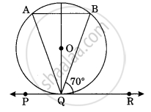a. 16 : 81 b. 4 : 9 c. 3 : 2 d. 2 : 3

7. In figure, if PQR is the tangent to a circle at Q   
 whose centre is O, AB is a chord parallel to   
 PR and $∟AQB$ is equal to

a. 20° b. 40°   
 c. 35° d. 45°

8. If radii of two concentric circles are 4cm and 5cm then the length of each   
 chord of one circle which is tangent to the other circle is

a. 3cm b. 6cm c. 9cm d. 1cm

9. The ratio in which the line segment joining the points A(3, -4) and B(-2,7)   
 is divided by x- axis is

a. 3 : 2 b. 2 : 3 c. 4 : 7 d. 7 : 4

10. The point which lies on the perpendicular bisector of the line segment   
 joining the points A(-2, -5) and B (2, 5) is

a. (0, 0) b. (0, 2) c. (2, 0) d. (-2, 0)

11. If sin + cos = cos , ≠ 90°, then tan = ________.

a. - 1 b. + 1 c. d. -

12. If x tan60°cos60° = sin60°cot60° then x =

a. cos30° b. tan30° c. sin30° d. cot30°

13. If the height of a flagstaff is twice the height of the tower on which it is   
 fixed and the angle of elevation of the top of the tower as seen from a   
 point on the ground is 30° then the angle of elevation of the top of the   
 flag staff as seen from the same point is

a. 45° b. 30° c. 60° d. 90°

14. If the area of a circle is 64 cm2 , then its circumference is

a. 7 $π$ cm b. 16 $π$ cm c. 14 $π$ cm d. 21cm

15. The arc of a circle of radius 30cm having length 19cm then the angle   
 subtended by this arc at the centre O of the circle is

a. 36.27° b. 36° c. 30.99° d. 34°

16. The mean of first n odd natural numbers is $\frac{n^{2}}{81}$ then n =

a. 9 b. 81 c. 27 d. 18

17. From the letters of the word “MOBILE”, if the letter is selected then the   
 probability that it is a vowel is

a. b. c. d.

18. A number x is chosen at random from the numbers -3, -2, -1, 0, 1, 2, 3.   
 The probability that $\left|x\right|$ < 2 is

a. $\frac{5}{7}$ b. $\frac{2}{7}$ c. $\frac{3}{7}$ d. $\frac{1}{7}$

**Direction:** In the question number 19 and 20, Assertion (A) is followed by a   
 Reason (R). Choose the correct option.

a. Both assertion (A) and reason (R) are true and reason (R) is the correct   
 explanation of assertion (A).

b. Both assertion (A) and reason (R) are true and reason (R) is not the   
 correct explanation of assertion (A).

c. Assertion (A) is true but reason (R) is false.

d. Assertion (A) is false but reason (R) is true.

19. **Assertion (A):** If x + 1, 3x and 4x + 2 are in A.P then x = 3.

**Reason (R):** If the seventh term of an A.P is $\frac{1}{9}$ and its ninth term is $\frac{1}{7}$ then   
 its 63rd term is 1.

20. **Assertion (A):** Three cubes each of volume 8 cubic centimeters are   
 joined end to end to form a cuboid. The surface area of the resulting   
 cuboid is 28cm2.

**Reason (R):** If n cubes each of volume a3 cubic units are joined end to   
 end to form a cuboid then the surface area of the resulting cuboid is   
 2(2n +1) a2 square units.

***SECTION B***

***Section B consists of 5 questions of 2 marks each.***

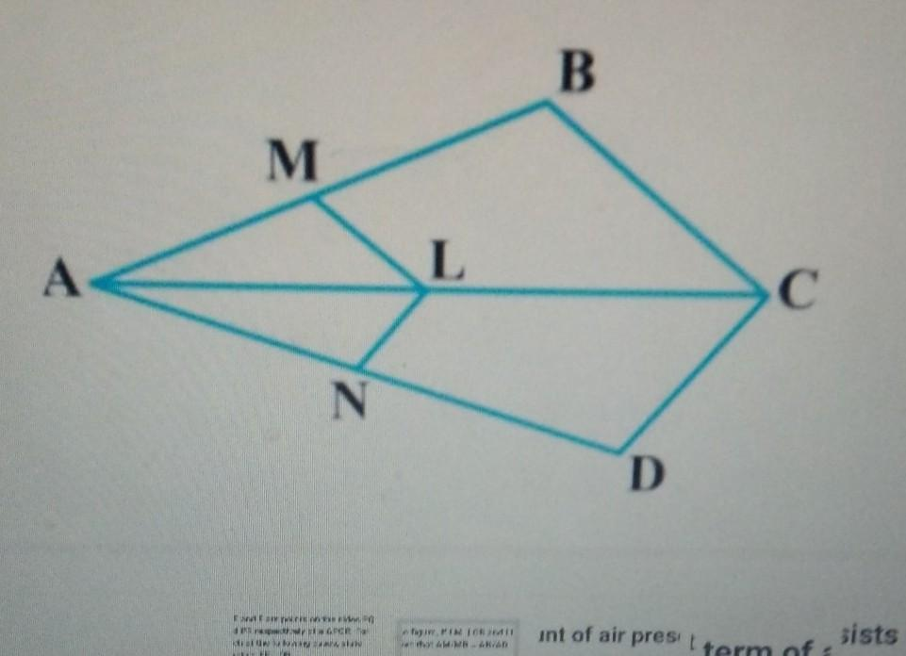21. If the HCF of 35 and 45 is 5, LCM of 35   
   
 and 45 is 63xa, then find the value of a.

22. In figure, if LM $∥$ CB and LN CD, prove   
   
 that = .

23. Prove that the tangents drawn at the ends of a diameter of a circle are   
 parallel.

24. If sin (A-B) = $\frac{1}{2}$, cos (A+B) = $\frac{1}{2}$, 0° < A+B < 90°, A > B, find A and B.

**OR**

In a ∆ABC, right angled at B, $∟A$ = $∟C,$ find the value of

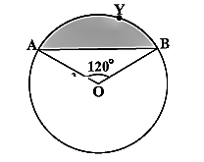 i. sinAcosC+cosAsinC ii. sinAsinB+cosAcosB

25. In a circle of radius 21cm, an arc subtends an   
 angle of 60° at the centre. Find i) the length of an

arc. ii) Area of the sector formed by the arc.

**OR**

Find the area of the segment AYB, if radius of the   
 circle is 21cm and $∟AOB$ **=** 120°. (Use $π$ = $\frac{22}{7}$)

***SECTION C***

***Section C consists of 6 questions of 3 marks each.***

26. Prove that is an irrational number.

27. Find the zeros of the polynomial f(x) = 4 x2 + 5x - 2 and verify the   
 relationship between the zeros and its coefficients.

28. Determine the value of a and b for which the following system of linear   
 equations has infinitely many solutions:  
 2x– (a-4)y = 2b + 1 ; 4x–(a-1)y = 5b-1

**OR**

In a ∆ABC, $∟C$ = 3 $∟B$ = 2 ( $∟A$ + $∟B$). Find the three angles.

29. Two tangents TP and TQ are drawn to a circle with centre O from an   
 external point T. Prove that $∟PTQ$ = 2 $∟OPQ.$

**OR**

Prove that a parallelogram circumscribing a circle is a rhombus.

30. Prove that = .

31. Find the median of the following frequency distribution:

|  |  |  |  |  |  |  |
| --- | --- | --- | --- | --- | --- | --- |
| **Weekly**  **Wages (in Rs)** | 60-69 | 70-79 | 80-89 | 90-99 | 100-109 | 110-119 |
| **No. of days** | 5 | 15 | 20 | 30 | 20 | 8 |

***SECTION D***

***Section D consists of 4 questions of 5 marks each***

32. The speed of a boat in still water is 15km/hr. It can go 30km upstream   
 and return downstream to the original point in 4 hours 30 minutes. Find   
 the speed of the stream.

**OR**

If the roots of the equation (c2 – ab) x2 – 2 (a2 – bc) x + b2 – ac = 0 are   
 equal, Prove that either a = 0 (or) a3 + b3 + c3 = 3abc.

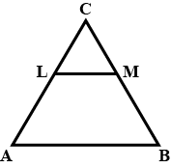33. State and Prove Basic Proportionality Theorem.  
   
 In figure, LM $∥$ AB. If AL= x – 3, AC = 2x, BM = x – 2 and   
 BC = 2x + 3, find the value of x.

34. A solid toy is in the form of a hemisphere surmounted by a right   
 circular cone. The height of the cone is 2cm and the diameters of the   
 base is 4cm. Determine the volume of the toy. If a right circular cylinder   
 circumscribes the toy, find the difference of the volume of the cylinder   
 and the toy. (Take $π$ = 3.14)

**OR**

Due to heavy floods in a state, thousands were rendered homeless. 50   
 schools collectively offered to the state Government to provide place and   
 canvas for 1500 tents to be fixed by the Government and decided to share   
 the whole expenditure equally. The lower part of each tent is cylindrical of   
 base radius 2.8m and height 3.5m, with conical upper part of the same   
 base radius but of height 2.1m. If the canvas used to make the tents costs   
 Rs. 120 per sq.m, find the amount shared by each school to set up the   
 tents.

35. The mean of the following frequency table is 50. But the frequencies f1   
 and f2 in class 20-40 and 60-80 are missing. Find the missing   
 information.

|  |  |  |  |  |  |  |
| --- | --- | --- | --- | --- | --- | --- |
| **C.I** | 0-20 | 20-40 | 40-60 | 60-80 | 80-100 | TOTAL |
| **FREQUENCY** | 17 | f1 | 32 | f2 | 19 | 120 |

***SECTION E***

***Case study based questions are compulsory.***

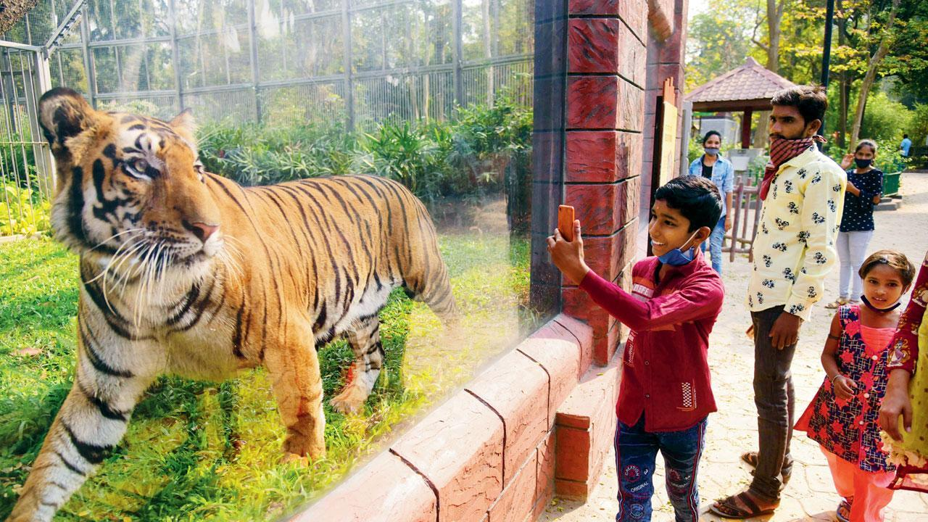36. In November 2020, some new animals were added to a zoo. As a result the number of visitors to the zoo, increased daily by 10. A total of 6150 people visited zoo during that month.

**Based on the above information, answer the following questions:**

i. How many visitors visited the zoo on 1st November?

ii. On which day of the month did 250 visitors visit the zoo?

iii. How many persons visited the zoo in the last 5 days of the month of   
 November?

**Or**

How much collection (in rupees) from sale of tickets was done in the zoo   
 on 15th November., if each entry ticket costs Rs. 50?

37. The following diagram shows the position of three electric poles A, B and   
 C in a society park.

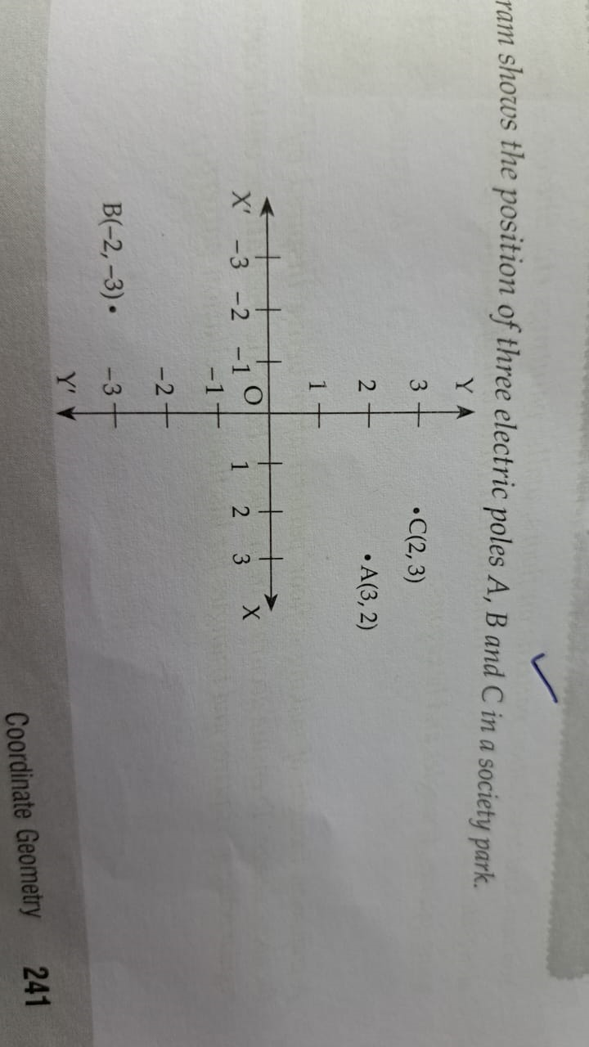 In spite of three poles in the park, the kids playing in the park   
 complained about darkness in the park, So the society president   
 decided to place 2 more poles in the park.

**Based on the above information, answer the following questions:**

i. Find the type of triangle formed by joining the points A, B and C.

ii. The fourth pole D is to be placed such that it divides the line segment   
 joining A and B in the ratio 2:3. Then find the coordinates of position of   
 pole D.

iii. The fifth pole is placed at a point E such that ABEC forms a $∥$ gm. Find   
 the coordinates of the point E.

**OR**

Find the coordinates of the point of intersection of diagonals of $∥$ gm ABEC.

38. Gadisar Lake is located in the Jaisalmer district of Rajasthan. It was   
 built by the King of Jaisalmer and rebuilt by Gadsi Singh in 14th   
 century. The lake has many Chhatris One of them is shown below:

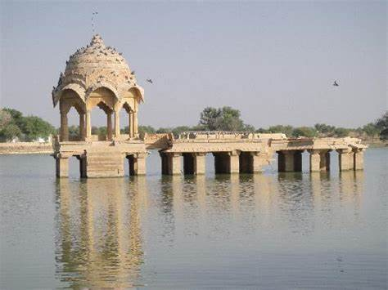

Observe the picture. From a point A, h meters above from water level, the angle of elevation of top of Chhatri (point B) is 45° and angle of depression of its reflection in water (point C) is 60°. If the height of Chhatri above water level is (approximately) 10m, then

i. Draw a well- labeled figure based on the above information:

ii. Find the length (h) of the point A above water level. (Use $\sqrt{3}$ = 1.73)